NAME: ANN MANOTI

The Mission:

1. Data Dive (10 pts):

* Pick your dataset and click to download ([Social Media Users](https://drive.google.com/file/d/1_pw30q72z-09Arcu4dfnS4CUCUsNUx-G/view), [Netflix Shows](https://drive.google.com/file/d/1Cth8F5M7smd4uqE7QNX6vHBSOdK_eank/view?usp=sharing), or [Human Stampedes](https://drive.google.com/file/d/1_pw30q72z-09Arcu4dfnS4CUCUsNUx-G/view)).

I picked the dataset of Netflix Shows.

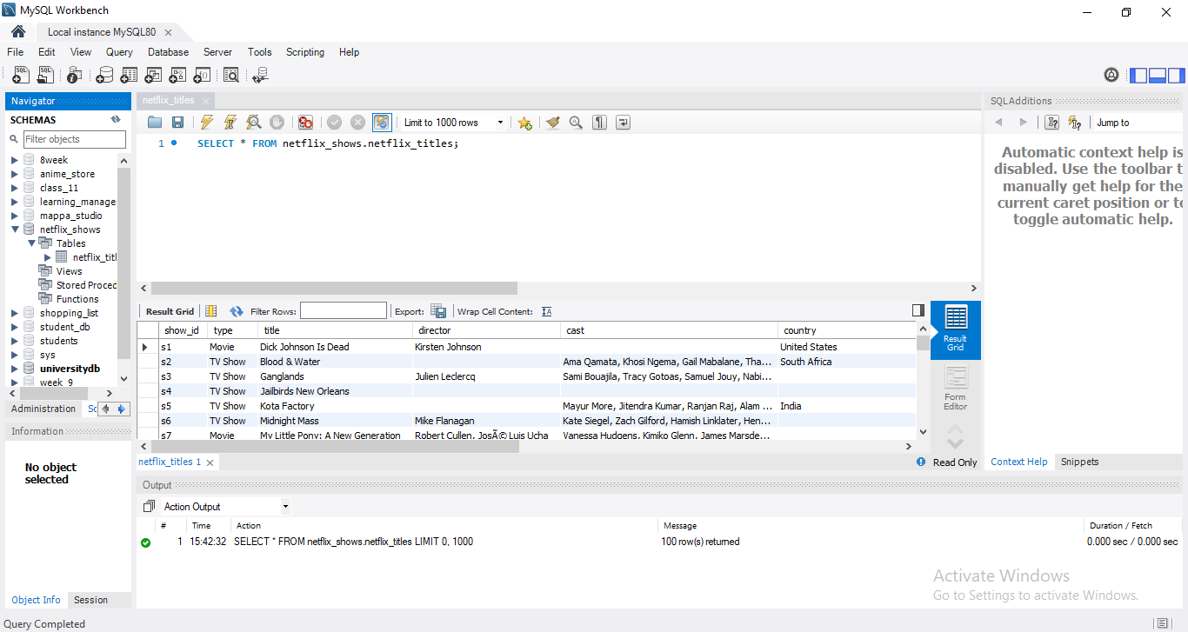

* Briefly explain any difficulties and 1 interesting thing you noticed about your chosen dataset.

While importing the dataset, I noticed that some of the fields were missing an entry and yet there was no error response upon executing the query.

I faced the challenge of not being able to import all the data, only managing to import a hundred to my workbench.

2. Data Fun (20 pts):

* Use simple SQL queries to play with the data.
* Find 2 cool facts hidden within the data (e.g., most popular interests).
* Use basic SQL queries like (COUNT, AVG, and SUM) to understand more about the data you have.

1. Counting the number of titles added per year

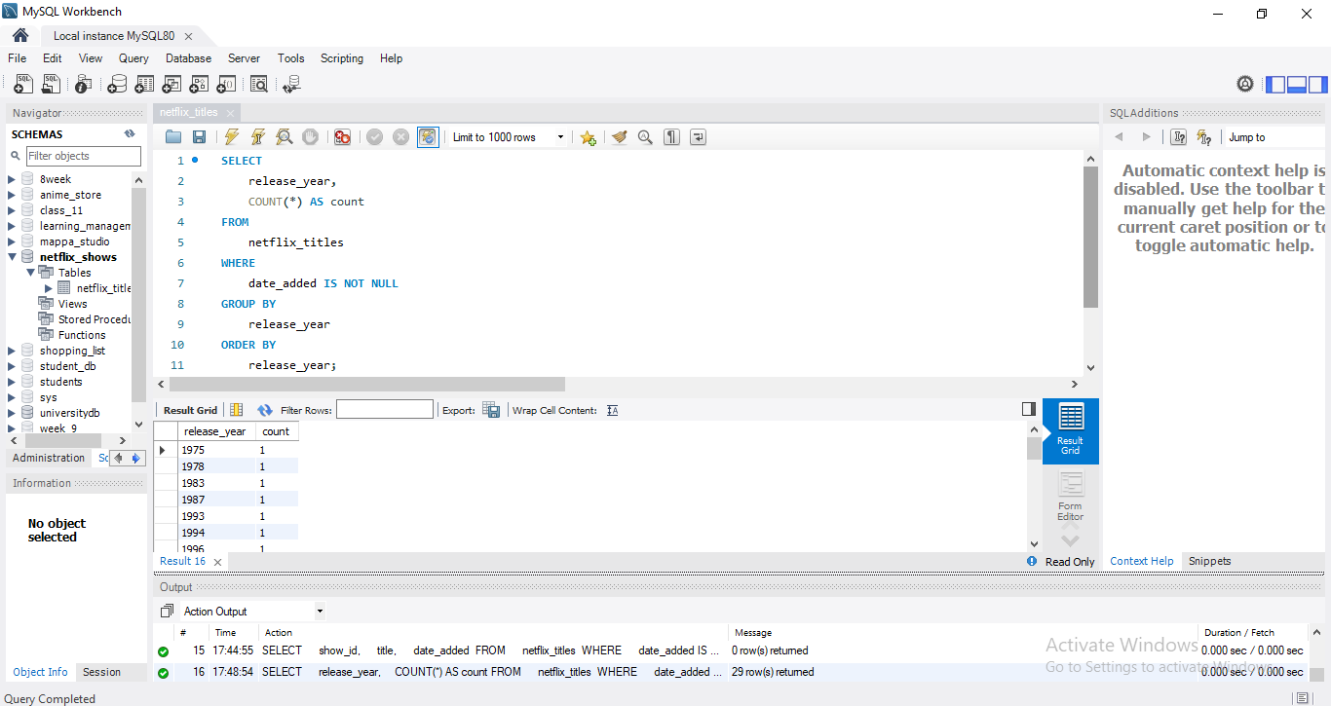

1. Finding the Longest Duration Movie or TV Show

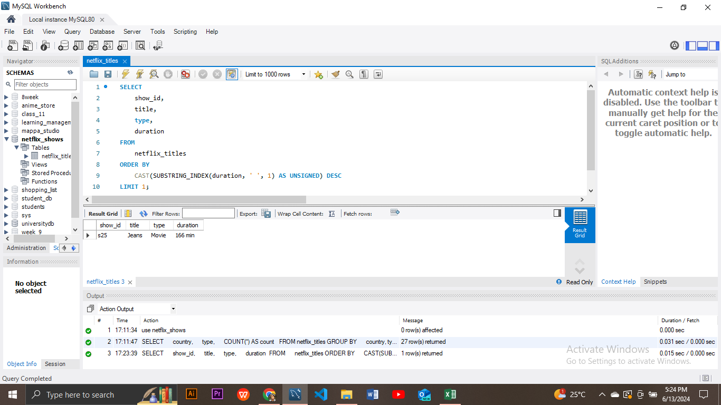

3. Ask Away (30 pts):

* Formulate 2 questions about the data (e.g.,what are popular shows in different countries?).
* Write basic SQL queries (WHERE, ORDER BY) to find answers.

1. What are the top 5 most popular TV shows (type = 'TV Show') released in the last 5 years (2017-2021) listed under documentaries, dramas and thrillers?

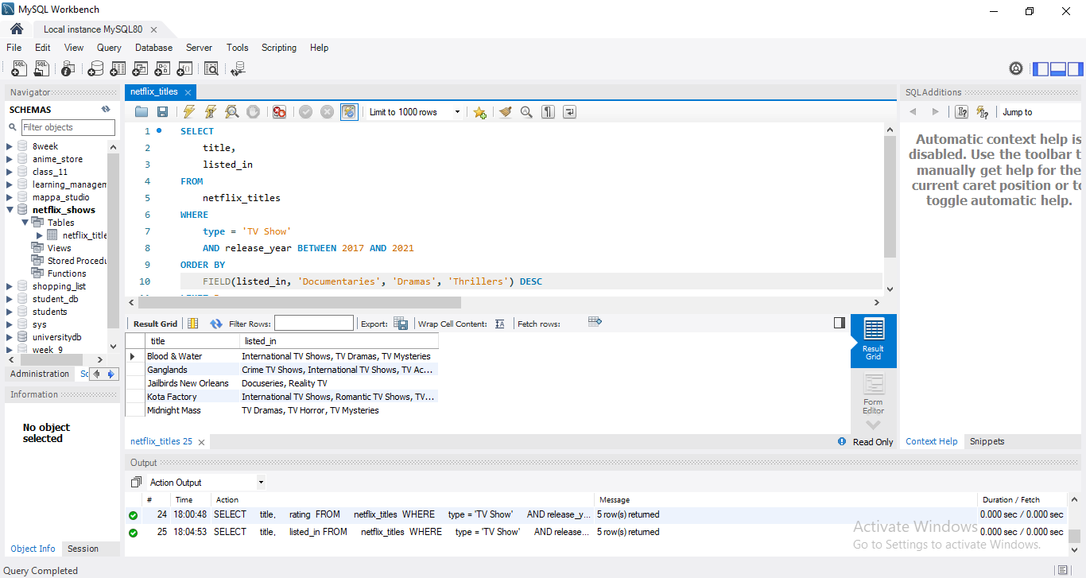

1. 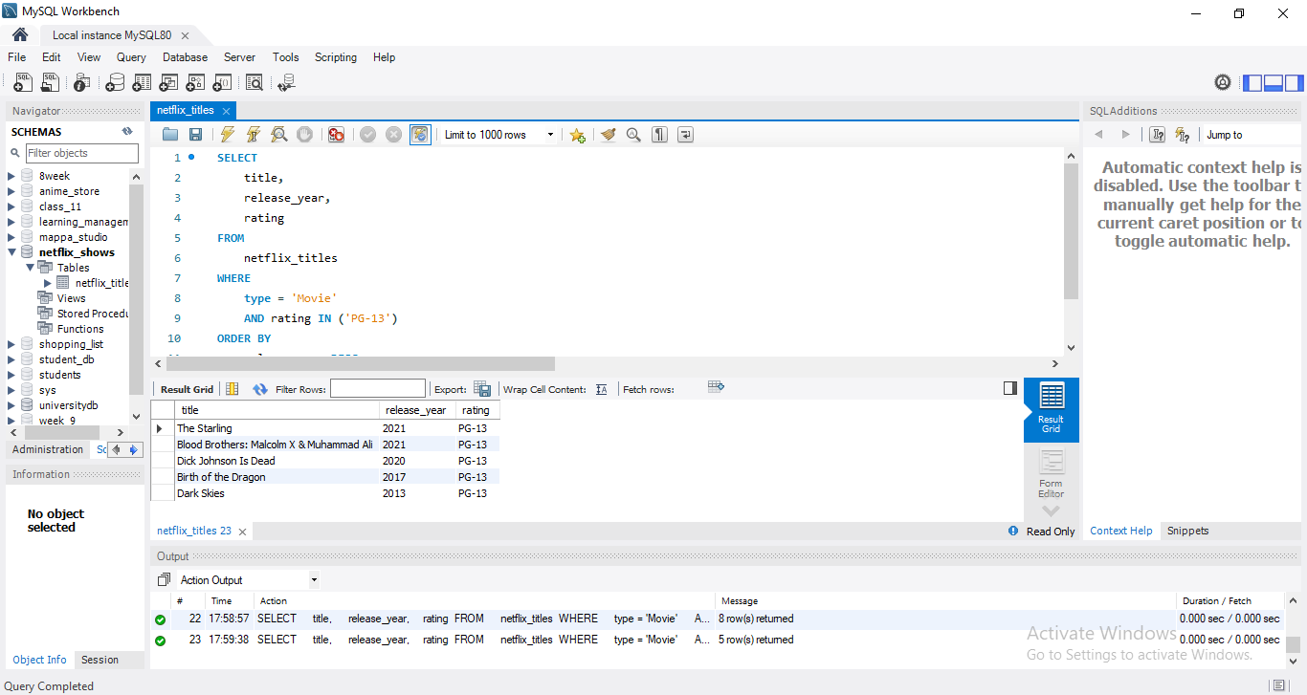What are the top 10 movies (type = 'Movie') with a PG-13 rating in descending order of release year?